***Abstract – Wind tunnels are used for research in various areas of research of wind and aerodynamics. The wind tunnel in the University of Puerto Rico, Mayagüez Campus is overly outdated, and recording data using it can be inconvenient. We propose NAME OF PROJECT , a system that would improve the current wind tunnel in an important way. NAME OF PROJECT would make recording data much simpler than it currently is, and could help make research easier in the future for constants users of the tunnel.***

Introduction:

Wind tunnels [1] are large tubes where an object is placed, and air is blown from powerful fans in a way that the air passes said object. The behavior of the object varies, depending on the *aerodynamic* characteristics of it. Therefore, we may say that wind tunnels are good tools to simulate the behavior of the objects in free flight. Some examples of objects that might be placed in wind tunnels are scaled-down versions of new airplane models, or cars with and without spoilers (in order to test how effective the spoilers are).

Numerous institutions around the world use wind tunnels. Some examples are NASA, the University of Maryland [2], and the University of Southampton [3]. The Civil Engineering Department of the University of Puerto Rico, Mayagüez Campus [4] has a small wind tunnel used for research. In the past, this tunnel has been a central part of analyzing the aerodynamics of numerous projects, such as a Solar Car, ailerons, and tanks of storage for fluids.

Unfortunately, this particular wind tunnel was made around 20 years ago, and renewal of it has not been done. The conditions of the laboratory containing the wind tunnel can be considered of severely poor quality by today’s standards. For example, two of the computers in the Wind Tunnel laboratory have 16 MB of onboard memory, and 424 MB of hard drive space.

Another component of the tunnel which is in deplorable conditions is also one it’s main components. This component is the mechanical balance that holds the model being analyzed. The balance of this particular tunnel is composed various steel bars connected together. These bars have halves of plastic milk bottles hanging from the bars. Figure 1 shows an image of the mechanical balance.

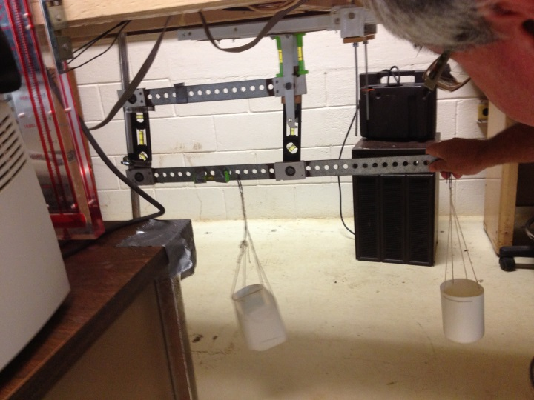

*Figure 1: Mechanical Balance of UPRM’s Wind Tunnel.*

Whenever an object is placed in the tunnel and the wind is blown, the balance is tilted. An example of the tilted balance can be seen in Figure 2. The direction of the tilt depends on the characteristics of the model being used. The data from the balance is obtained by pouring sand on whichever half of the cup needs it in order to balance the device until it is close to 90 degrees, as it was from the start. After the desired angle has been achieved, the user takes the plastic cup and weights the poured sand. Calculations are then made using the measurement and then the process of getting the needed data can continue.

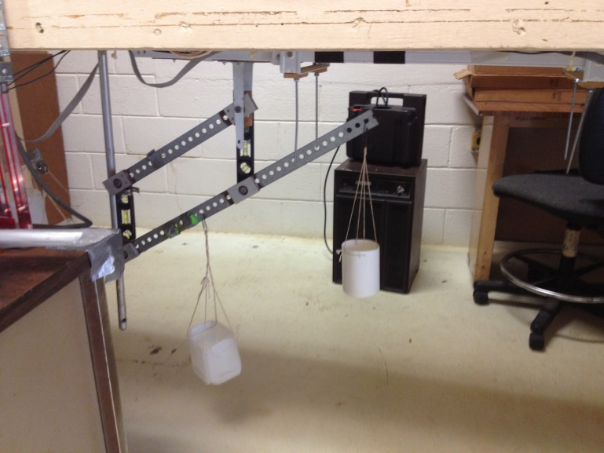

*Figure 2: Tilted Balance.*

It is not hard to imagine how tedious and inconvenient the process of obtaining the data using the mechanical balance of this particular wind tunnel is. Science fair projects from recent years have tried to make solutions to improve the tediousness of the mentioned process, all of them to no avail. We propose an electronic system to renew the mechanical balance, having a microprocessor as a central point, in order to significantly improve wind tunnel as a whole. Our model would modernize the current tunnel in a meaningful way without having the economic implications of buying an entire new system.

Bibliography:

[1] <http://www.nasa.gov/audience/forstudents/k-4/stories/what-are-wind-tunnels-k4.html>

[2] <http://windvane.umd.edu/>

[3] <http://www.southampton.ac.uk/windtunnels>

[4] <http://ingenieria.uprm.edu/inci/mod/page/view.php?id=33>

Expert Opinion:

**Dr. Eduardo Ortiz-Rivera** (Professor of the Department of Electrical and Computer Engineering in the University of Puerto Rico, Mayagüez Campus).

* An important characteristic of the system should be to use two accelerometers and compare values of both, in order to get the best precision possible. A gyroscope should be considered as well.
* Bluetooth or some other of wireless communication to an external device has to be a part of the project. If the idea is to make the researcher have a more convenient system, then having to bend down to collect the data through something like an SD Card should be evaded.
* Value of the device should be considered; if it is low enough, then it could be marketable.
* The system currently used should not be thrown away. Although it is not convenient to use, it is reliable in the sense that it can always be used in case our system malfunctions, plus it does not need electricity to work.